* Create a way to put information in the spreadsheet, we need to find a way to analyze this line of characters:



Some times the unix mix is in different formats, and what we want is to be able of getting the amount of bedrooms and bathrooms that the current property has.



Also you will have to copy the current rents of the property.

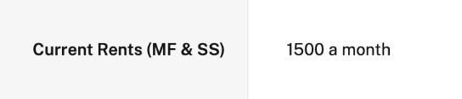

This information will be pasted in the spreadsheet on this part of the leads’s template

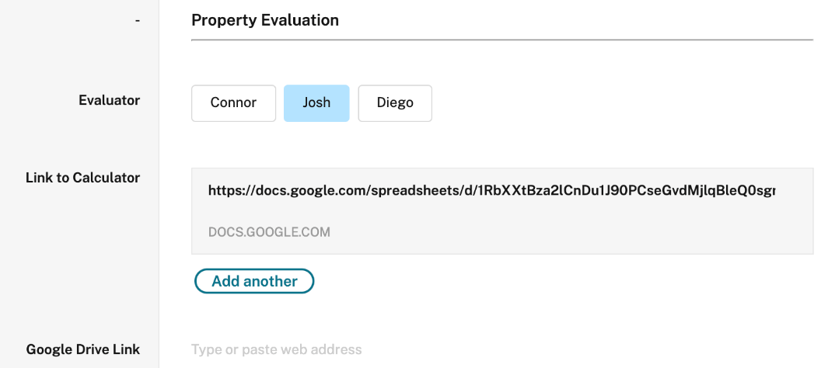

And when you open that this is where you have to put the scraped information

* Verify that we can send ourOffer in index-autorespond.js